Luminous intensity and chromaticity distribution measurement for LED modules and luminaires
Jianping Wang¹, Jiandong Yu¹, Tongsheng MOU²
¹Zhejiang University Sensing Instruments Co., Ltd, Hangzhou, China
²Optical Engineering Department of Zhejiang University, Hangzhou, China

abstract
As the LED application in general lighting develops rapidly, people have paid more attention to the quality of LED lighting, and the measurement of the spatial light, and color distribution of LED modules and luminaires is one of the hot topics concerned at present. In this paper, a gonio-colorimeter measurement was presented. A new Type C [1] goniophotometer was introduced, and a fast and accurately colorimetric solution for the measurement of spatial chromaticity non-uniformity was used.
Keywords: Goniophotometry, spatial chromaticity difference, LED photometry.

1. INTRODUCTION
In recent years, the LED application in general lighting develops rapidly. Therefore, how to evaluate the quality of LED lighting accurately has become much more important, and the measurement of the spatial light distribution of LED modules and luminaires is one of the hot topics concerned at present. However, it is more challenging to measure the spatial luminous intensity and chromaticity distribution of LEDs. Primarily, the light output, peak wavelength, and chromaticity of LED are closely related to the junction temperature. As Figure 1 shows, the spectral distributions, luminous flux and chromaticity coordinates were obviously changed when tested under different ambient temperatures. Besides, the light beam of LED luminaires maybe quite complicated (Figure 2). Furthermore, the light output of LED modules and luminaries may have spatial non-uniformity of chromaticity (Figure 3), and this non-uniformity is related to the light distribution, near distance measurement cannot actually reflect the spatial color non-uniformity of LED luminaries (Figure 4). Consequently, appropriate gonio-colorimeter measurement for LED modules and luminaries has to be studied.
Figure 1. Spectrum of a green LED at different temperatures (from Schanda et al [2]).

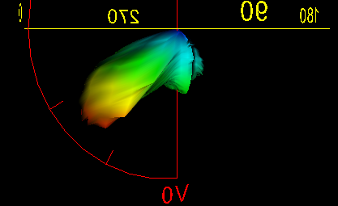
Figure 2. The luminous intensity distributions of a typical LED luminaire.

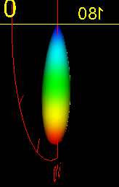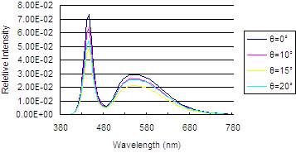
Figure 3. The luminous intensity distributions of a typical LED module (Left) and the spectral intensity distributions of the LED module at θ=0°, 10°, 15°, 20° (Right) as Figure 9 shows.

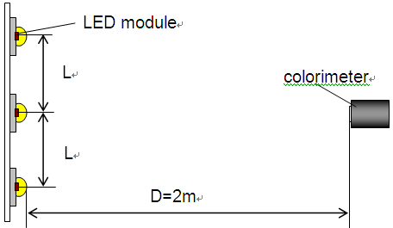
Figure 4. The chromaticity coordinate of a LED luminaire was determined by a colorimeter at θ=0°, and the measuring distance is 2m.

As Figure 4 shows, the chromaticity coordinate of a LED luminaire was determined by a colorimeter at a 2m distance (θ=0°). There are three same LED modules in the luminaire, the luminous intensity and the spectral intensity distributions of each LED module was shown in Figure 3, and the distance between each LED module was L. As Table 1 shows, while the distance between LED modules (L) changes, the chromaticity coordinate measured at θ=0° changes when the measurement distance is 2m. Obviously, near distance measurement cannot actually reflect the spatial color non-uniformity of LED luminaries.

Table 1. Test results under near distance measurement (2m distance) and far field measurement.
 | x | y
Result under far field measurement condition | 0.3014 | 0.3012
L=705 mm | 0.3026 | 0.3035
L=1072mm | 0.3035 | 0.3061
L=1456mm | 0.3072 | 0.3125

2. RequireMents of gonio-colorimeter measurement for LEDs
For present LED products, as mentioned above, the following requirements have to be considered:
- The control of the junction temperature of the LEDs (Figure 1).
- The measuring distance shall be long enough.
- Both the light intensity and color non-uniformity has to be determined.
Consequently, a gonio-colorimeter with pursuit mirror is introduced.

3. A Gonio-colorimeter with Pursuit Mirror
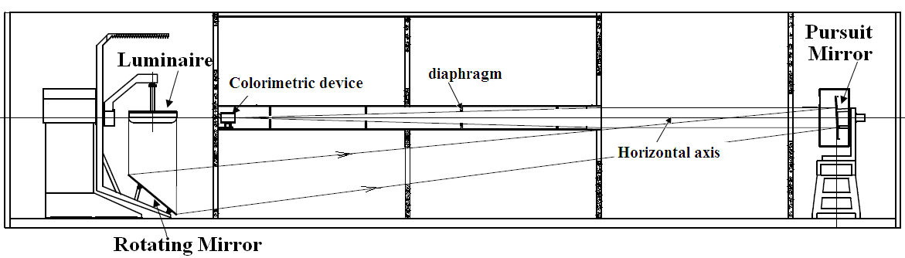
Figure 5. Gonio-colorimeter with pursuit mirror.

As Figure 5 shows, the gonio-colorimeter with pursuit mirror [3] is a typical Type C gonio-colorimeter which can maintain the burning position of LED samples under test unchanged with respect to gravity. The LED under test is installed in the photometric centre of the gonio-colorimeter. As the light output, peak wavelength, and chromaticity of LEDs are closely related to the junction temperature, a thermostatic adapter (Figure 6) is installed on the gonio-colorimeter to maintain the junction temperature of the LED. A rotating mirror rotates around the horizontal axis, through the photometric centre of the gonio-colorimeter. Besides, a pursuit mirror, also rotates around the horizontal axis, is placed in the reflection beam path of the rotating mirror, and rotates with the rotating mirror synchronously. Furthermore, the reflection beam axis of the pursuit mirror and the horizontal axis always superpose each other. A colorimetric device is placed in the reflection beam path of the pursuit mirror. Consequently, the light output from the luminaire under test first reflected by the rotating mirror, and then reflected by the pursuit mirror, and finally goto the colorimetric device. Accordingly, the measurement distance can almost be doubled while the gonio-colorimeter occupies the same room space.
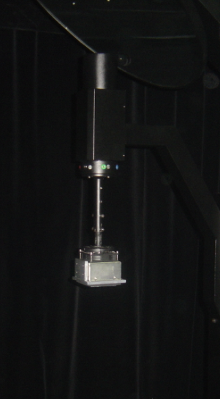
Thermostatic adapter
Figure 6. Thermostatic adapter installed Gonio-colorimeter with pursuit mirror.

In this way, the measurement distance can be long enough, accordingly large dimension or complicated beam LEDs can be determined accurately. Besides, the colorimetric device can be installed in a fixed place, less uncertainty can be achieved comprared with the moving detector while measuring. Meanwhile, since the beam path from the pursuit mirror to the fixed detector is constant, it’s conveniently to set diaphragms between both of them to eliminate stray light. Besides, annular aperture between the rotating mirror and the pursuit mirror also can be set to reduce the stay light.

4. chromaticity distribution MEASUREMENT

4.1 Colorimeter
In order to determine the chromaticity distribution of the LED, both colorimeter and spectroradiometer [4] can be used. However, although an array spectroradiometer mounting on a goniophtometer can measure the spatial spectral distribution, but longer exposure time is necessary under low light level at far photometric distance, and this greatly limits the application of goniophotometers with moving mirror in continuous rotating measurement. Therefore, the measurement of spatial chromaticity difference based on a four-color detector colorimeter corrected by the measurement of a spectroradiometer is introduced to achieve accuracy and time efficiency.
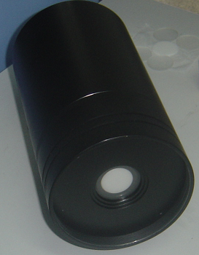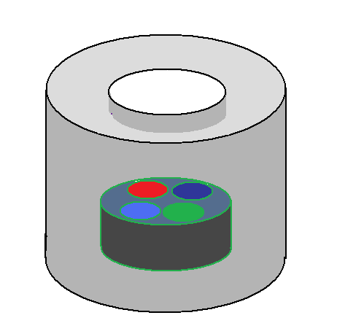
Photodiode
Filter
diffuser
filter
Figure 7. Schematic and photograph of the four-color detector colorimeter.

There are four-color photodiodes used in the colorimeter as shown in Figure 7. The spectral transmittance of four color filters was specifically designed to match the spectral transmission characteristics of the diffuser and the photodiodes so that the combined diffuser-filter-photodiode spectral response would be as close as possible to the CIE 1931 2 degree observer color matching functions [5]. The spectral response curves of the colorimeter is shown in Figure 8. The computer-controlled colorimeter records four color detector signals, X’b, X’r, Y’, and Z’. Accordingly, Once the colorimeter has been properly calibrated, the CIE 1931 chromaticity coordinates may then be determined.
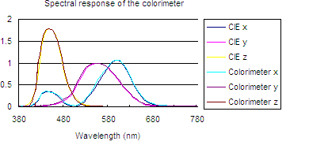
Figure 8. The spectral response of the Colorimeter.

4.2 Calibration
Generally, the colorimeter was calibrated by using a NIST traceable Illuminant A light source. The photodiodes captured radiation of the illuminant A light source using the X’b, X’r, Y’, and Z’ filters and the known chromaticity coordinates along with the ratios of Xb/X’b, Xr/X’r, Y/Y’, and Z/Z’ were entered into the colorimeter software. However, the measurement difference between a high accuracy spectroradiometer and the colorimeter can be △x=0.003, △y=0.002 (Table 2). Consequently, correction methods have to be studied to the colorimeter after calibrated.
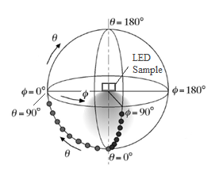
Figure 9. Geometry for the chromaticity measurement using a goniometer (the figure shows the case for a LED product emitting light in downward directions only).

The correction of the colorimeter was performed in three ways. First, use the colorimeter to determine the chromaticity distribution, and using the color difference between the test results of the colorimeter and a high accuracy spectroradiometer at θ=0° (Figure 9 [6]) to correct the test results of the colorimeter. For instance:
x_{θ}=x’_{θ}+ (x₀-x’₀) (1)
where x_{θ} is the corrected result of the colorimeter at θ, x’_{θ} is the test result of the colorimeter at θ, x₀ is the test result of a high accuracy spectroradiometer, x’₀ is the test result of the colorimeter at θ=0°. y’_{θ} and z’_{θ} were also corrected in this way.
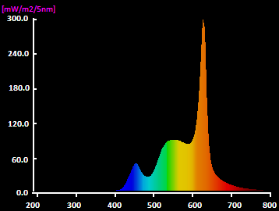
Figure 10. The spectral distributions of the 2782K LED module.

A LED module was tested, whose correlated color temperature is about 2782K at θ=0° (Figure 10). Table 2 shows the test results of a LED module, and Figure 11 shows the spectral distributions of the LED module at the direction of different angle θ.
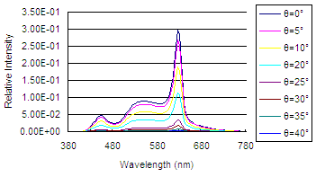
Figure 11. The spectral distributions of a 2782K LED module at θ=0°, 5°,10°, 20°, 25°, 30°, 35°, 40°.

Table 2. Test results of the colorimeter corrected in the first way for a 2782K white LED measurement.
 | High accuracy spectroradiometer |  | Calibrated by A2856 |  | Corrected
θ | x | y | x | y | x | y
0 | .4512 | .4052 | .4484 | .4069 | .4512 | .4052
5 | .4514 | .4049 | .4486 | .4066 | .4514 | .4049
10 | .4489 | .4053 | .4461 | .4070 | .4490 | .4053
20 | .4458 | .4032 | .4430 | .4048 | .4460 | .4033
25 | .4403 | .4025 | .4377 | .4040 | .4406 | .4025
30 | .4360 | .4013 | .4335 | .4027 | .4365 | .4013
35 | .4292 | .4001 | .4269 | .4013 | .4300 | .4001
40 | .4292 | .3993 | .4267 | .4006 | .4298 | .3994

The second correction method is also based on a high accuracy spectroradiometer.
(2)
Where Z_{θ} is the corrected result of the colorimeter at θ=0°, Z(λ) is the CIE 1931 2 degree observer color matching functions, S_{Z}(λ) is the spectral response of the colorimeter. P⁰_{LED}(λ) is the spectral distribution of the LED module determined by the high accuracy spectroradiometer at θ=0°. P^{θ}_{LED}(λ) is the real spectral distribution of the LED module. X_{bθ}, X_{rθ}, and Y_{θ} were corrected in the same way. Table 3 shows the test results of the 2782K LED module corrected in the second way.

Table 3. Test results of the colorimeter corrected in the second way for a 2782K white LED measurement.
 | High accuracy spectroradiometer |  | Calibrated by A2856 |  | Corrected
θ | x | y | x | y | x | y
0 | .4512 | .4052 | .4484 | .4069 | .4512 | .4052
5 | .4514 | .4049 | .4486 | .4066 | .4514 | .4049
10 | .4489 | .4053 | .4461 | .4070 | .4490 | .4053
20 | .4458 | .4032 | .4430 | .4048 | .4459 | .4032
25 | .4403 | .4025 | .4377 | .4040 | .4405 | .4024
30 | .4360 | .4013 | .4335 | .4027 | .4363 | .4011
35 | .4292 | .4001 | .4269 | .4013 | .4297 | .3998
40 | .4292 | .3993 | .4267 | .4006 | .4296 | .3991

The third correction way is to use a normal spectroradiometer.
x_{θ}=x’_{θ}+ (x₀₁-x’₀) (3)
where x_{θ} is the corrected result of the colorimeter at θ, x’_{θ} is the test result of the colorimeter at θ, x₀₁ is the test result of a normal spectroradiometer, x’₀ is the test result of the colorimeter at θ=0°. y’_{θ} and z’_{θ} were also corrected in this way.
Figure 12 shows the measurement difference between a normal spectroradiometer and a high accuracy spectroradiometer.

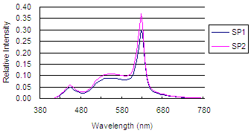
Figure 12. The spectral distributions of the LED module tested by a high accuracy spectroradiometer and a normal spectroradiometer.

Table 4. Test results of the colorimeter corrected by a normal spectroradiometer for a 2782K white LED measurement.
 | High accuracy spectroradiometer |  | Calibrated by A2856 |  | Corrected
θ | x | y | x | y | x | y
0 | .4512 | .4052 | .4484 | .4069 | .4513 | .4052
5 | .4514 | .4049 | .4486 | .4066 | .4515 | .4049
10 | .4489 | .4053 | .4461 | .4070 | .4491 | .4053
20 | .4458 | .4032 | .4430 | .4048 | .4460 | .4033
25 | .4403 | .4025 | .4377 | .4040 | .4407 | .4025
30 | .4360 | .4013 | .4335 | .4027 | .4366 | .4013
35 | .4292 | .4001 | .4269 | .4013 | .4300 | .4001
40 | .4292 | .3993 | .4267 | .4006 | .4299 | .3994

As Table 2, Table 3 and Table 4 show, while the colorimeter was corrected in the first way, the measurement difference between the high accuracy spectroradiometer and the colorimeter can be reduced to △x=0.0008, △y=0.0001, while the colorimeter was corrected in the second way, the measurement difference between the high accuracy spectroradiometer and the colorimeter can be reduced to △x=0.0005, △y=0.0003, and while the colorimeter was corrected using a normal spectroradiometer, the measurement difference between the high accuracy spectroradiometer and the colorimeter can be reduced to △x=0.0008, △y=0.0001.

5. CONCLUSIONS
We have shown that a gonio-colorimeter is capable of measuring LED modules and luminaries containing luminous intensity and chromaticity distribution. The gonio-colorimeter can maintain the burning position of LED samples under test unchanged with respect to gravity, and it has long measuring distance and excellent elimination of the stray light. Three correction methods for the colorimeter were used, the colorimeter showed substantial improvement in color measurement accuracy over the calibration method using only Illuminant A, and the test results agree well with similar measurements made with a high accuracy spectroradiometer. Consequently, when using both a spectroradiometer and a colorimeter, the gonio-colorimeter can greatly improve color measurement accuracy and maintain the time efficiency.

references
1. IESNA Testing Procedures Committee, Goniophotometer Types and Photometric Coordinates, LM-75-01.
2. CIE Publication No. x022, Proceedings of the 2ND CIE Expert Symposium on LED Measurement: Standard methods for specifying and measuring LED and LED cluster characteristics, Central Bureau of the CIE, Vienna, Austria, 2001.
3. Tongsheng Mou, A Novel Goniophotometer with Pursuit Mirror, 2008 CIE Expert Symposium on "Advances in Photometry and Colorimetry", 7-8 July 2008, Turin, Italy.
4. Michael Shaw, Goniospectroradiometric chracterisation of light sources, 2008 CIE Expert Symposium on "Advances in Photometry and Colorimetry", 7-8 July 2008, Turin, Italy.
5. CIE Technical Report, COLORIMETRY, CIE Pub. NO. 15.
6. Approved Method: Electrical and Photometric Measurements of Solid-State Lighting Products, IES LM-79-08.

Acknowledgements
Jianping Wang
Zhejiang University
Sensing Instruments Co., Ltd
Hangzhou, China

Jiandong Yu
Zhejiang University
Sensing Instruments Co., Ltd
Hangzhou, China

Tongsheng Mou
Optical Engineering Department
of Zhejiang University
Hangzhou, China
Tel. +86 571 8502 1543
Fax: 86 571 8797 7635
e-mail: sensingm@163.com

